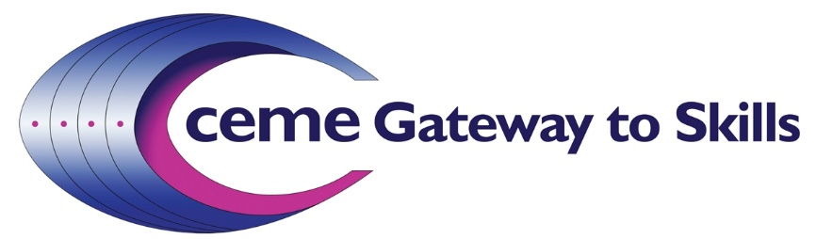

Background:
The Gateway to Skills (GTS) programme has been running since 2006 at the Centre for Engineering & Manufacturing Excellence (CEME) in East London.
CEME is an 18-acre campus that consists of five integrated elements; Launchpad (business launch and incubation), Innovation Centre (accelerated growth), Serviced offices (grow-on space), Integrated Classrooms and industrial workshops (upskilling) and a Conference Centre (social and business integration). Each of the elements are complementary to each other as they enable business growth, upskilling and new job creation which are three of the key outputs of the CEME operating model. The purpose of CEME is to provide an inspiring environment for learning and business growth. This is delivered daily to an exacting and consistent standard through living our organisational values of: Presentation, Exceeding Expectations and Positive Attitude.
Visit our website at: www.ceme.co.uk

Gateway to Skills:
The GTS programme provides a creative and inspiring `Taster Day` for local secondary level schoolchildren in years 7 – 10 from the London Boroughs of Newham, Havering and Dagenham & Barking (East Plus). Its objectives are to:
- Create greater awareness of STEM subjects in secondary school level students
- Stimulate students interest in Engineering and STEM in a fun and interesting environment outside of school
- Enhance existing and develop new personal skills in Technology and Construction
- Provide awareness of Engineering career options and scope of sector-wide application
- Help to increase the required number of future Engineers in the local area

The programme is run from dedicated facilities at CEME that provide an integrated classroom and workshop environment that is tailored to theoretical and practical learning by schoolchildren. The facilities also host a full IT suite of connected computers allowing students to learn from proprietary and bespoke content. In addition, a variety of supplies of building and engineering materials such as Knex blocks, electronic circuitry, robotics and software form part of the programme resources and enable construction of structures and ideas that require the principles of design and engineering to be applied.

Since 2006, the programme has delivered to well over 1000 schoolchildren from the London East Plus areas and we plan to expand this geographic coverage in the future.

GTS is designed to focus specifically on STEM subjects and to bring them alive in an interesting and fun way that will inspire schoolchildren to become more interested in these crucial subject areas.
Unfortunately, many secondary level schools in the East Plus area suffer from a lack of funding to be able to create and deliver a similar STEM programme of their own. Consequently, they are often unable to gain access to the specialist equipment and teaching and denied the opportunity to educate and inspire their students in this way. The GTS programme steps in to fill that gap to provide that necessary and valuable opportunity for the local schools. This means that they can still receive an interesting and high-quality, curriculum-based activity that supports their own teaching programmes without the need to find extra funding as the programme is delivered free-of-charge to the participating schools who are located within the London Boroughs of Havering, Newham and Barking & Dagenham.

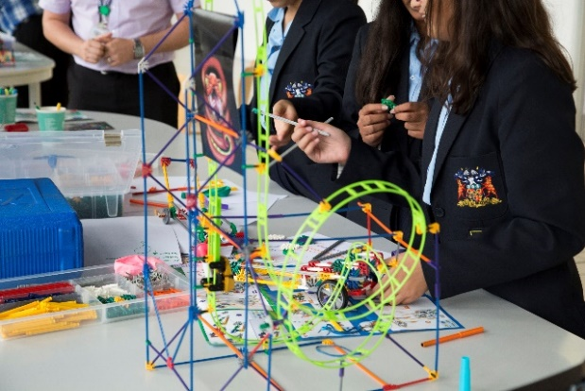

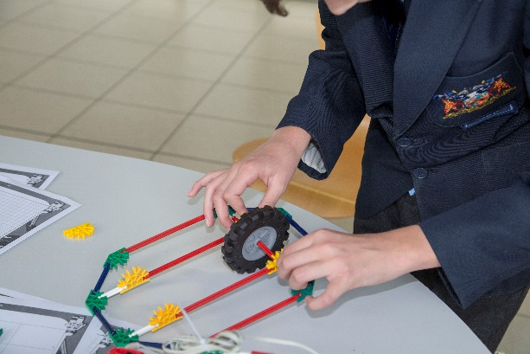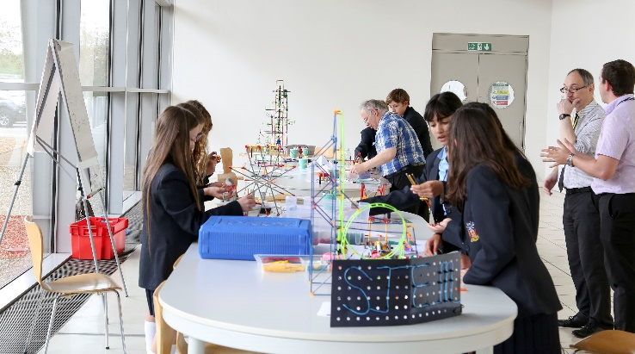

The current syllabus has been created to deliver a combination of information, personal challenge and activity in a fun and inspiring way that generates interest and excitement among the attending students. A typical Taster day timetable would look like:

09:00 – Depart School
09:45 – Arrive CEME
10:00 – 12:00 – Morning session covering 2 of the 4 STEM subjects
12:00 – 12:30 – Lunch break at CEME
12:30 – 14:30 – Afternoon session covering remaining 2 of the 4 STEM subjects
14:45 – Depart CEME and return to School

The Syllabus:

The current syllabus consists of 4 STEM-based subject areas; Electronics, Games Design, Knex (Construction) and Robotics.

Electronics - In the electronics activity, learners use a breadboard to construct basic electronic circuits from schematics or simple diagrams i.e. a 555 timer circuit. LEDs flashing (Astable) Light Dark circuit and many more. Interest in this area of STEM can lead to electronics courses and careers in electrical engineering, Control and instrument engineering, network engineering or broadcast engineering.
Games Design - The Games Design Activity uses GameMaker 8 to produce a fully working game breakout (with graphics & sound) which can be expanded to more complex games like shoot-em-up and platform games.
KNEX - In this activity, Knex interlocking parts are used to produce bridges and simple mechanical structures to solve engineering problems. The structures can also be used with motors to build cranes, Ferris wheels cars etc. With this activity, learners are given problems to solve like building a mouse trap, gearing system etc which develop problem solving skills along with hand/eye co-ordination.
Robotics - With the Robotics Activity, Circuit Wizard software is used to create flowcharts to program and control robots. They are programmed to move forward, reverse and to use sensors to detect obstacles and avoid them.
The syllabus has been recently refreshed to take into account advancing changes in technology and the opportunities that it creates. Recent additions have also included virtual reality (VR) equipment to supplement the learning.
In addition, the syllabus can also be tailored more towards a specific sector or relevant area of technology or commerce to support the business aims of the sponsoring organisation, if required.

Deliverables:

The current programme captures both quantitative and qualitative data from the participating students. To date the programme has delivered quantitatively:
21 taster days
740 students
Male: 60% Female: 40%

(source: CEME/Havering College, period: Sept 2016 – Feb 2018)

The programme also records qualitative data in the form of eight questions:

On a scale of 1 – 5, or above, how much did you enjoy the session? 71.85% ave (Yes)
Which activity did you enjoy the most? - all 4 subjects 83% ave (Yes)
Do you think it gave you a good idea of what STEM involves? - 87.5% ave (Yes)
Would you consider studying one of the STEM subjects after leaving school? 72% ave (Yes)
Would you consider a career in STEM? 68.5% ave (Yes)
Do you like the facilities at CEME? 91.5% ave (Yes)
Do you think the day was well organised? 90.5% ave (Yes)

(source: CEME/Havering College, period: Sept 2016 – Feb 2018)

Sponsorship:

The commercial sponsorship package is priced at £85,000. This provides for 1,000 student places that can be delivered over one or two academic years. The participating students would be currently from the London Boroughs of Newham, Havering and Barking & Dagenham (East Plus). However, it is planned to expand that area to also include other London Boroughs and South Essex schools whose location is close to the CEME campus.

In addition, the sponsoring organisation is also encouraged to provide (at their cost) a suitable piece(s) of branded collateral or useful item(s) that the students can take away with them after the day and keep. This gives the sponsor the opportunity to reinforce their financial involvement and support of the programme to both the students and parents, often as part of a corporate & social responsibility (CSR) campaign.

Student feedback forms are always used to capture their opinions on the quality of the syllabus, the facilities and their interest in participating again in STEM. Case studies of any students who have progressed further into STEM related studies or careers are also tracked, where identifiable.

PR & Communications:

Appropriate material would be made available for both parties to utilise. Some examples could be:
- Film footage of Taster Days being delivered
- Filmed interviews with school children
- Joint, local press releases to highlight the programme (if possible)
- School termly summaries of qualitative feedback from participants and teachers
- Monitoring of any `good news` stories involving any individual to use as case study for GTS

CEME would always be amenable to any reasonable request to work with a Sponsor in creating appropriate joint communications activity.

Future evaluation of sponsorship:
Evaluation of the sponsorship programme would be undertaken at the end of a sponsorship period. It is envisaged that the measurements used would be:
- Number of school children attending Taster Days
- Qualitative feedback on their experience and value derived – from schoolchildren and teachers
- Geographic reach and coverage of Schools, by Borough
- Case studies of impact and any positive effect in choice of subjects studied at higher level education, through a follow-up campaign. (subject to availability)
- Filmed interviews with participants of Taster Days

Next steps:

Please contact the CEME Business Development Director to discuss your corporate engagement.

E-mail: Graeme.hay@ceme.co.uk
Tel: 0208 596 7057

